**Report of visualization**

**Introduction of chosen dataset**

For this assignment, the data set selected was for men and women with unemployment rates from 1971 to 2018, with the aim of exploring the changing relationship between unemployment rates for different genders and the trends in the two years of unemployment. The purpose of selecting these two data is to explore the overall trend of unemployment rates for different genders and to predict future trends, and to explore the relationship between the two by comparing data from different genders.

**Data processing**

The first step is to process the data in order to filter out useful information. With panda, lines 9 through 56 of the dataset are selected, saved in the list with the for loop and used to store the data for each year. The content has the year, the female data, the male data, and finally the JSON file.

**Data visualization**

Line and histograms are used to represent the filtered data

**line chart**

The line chart is used to explore the overall trend of unemployment rates for men and women from 1971 to 2018 and to explore the links between the two. Because I want to show the total trend in these 45 years. I decide to show all of years in one line chart, rather than use more charts to show the data of different period.

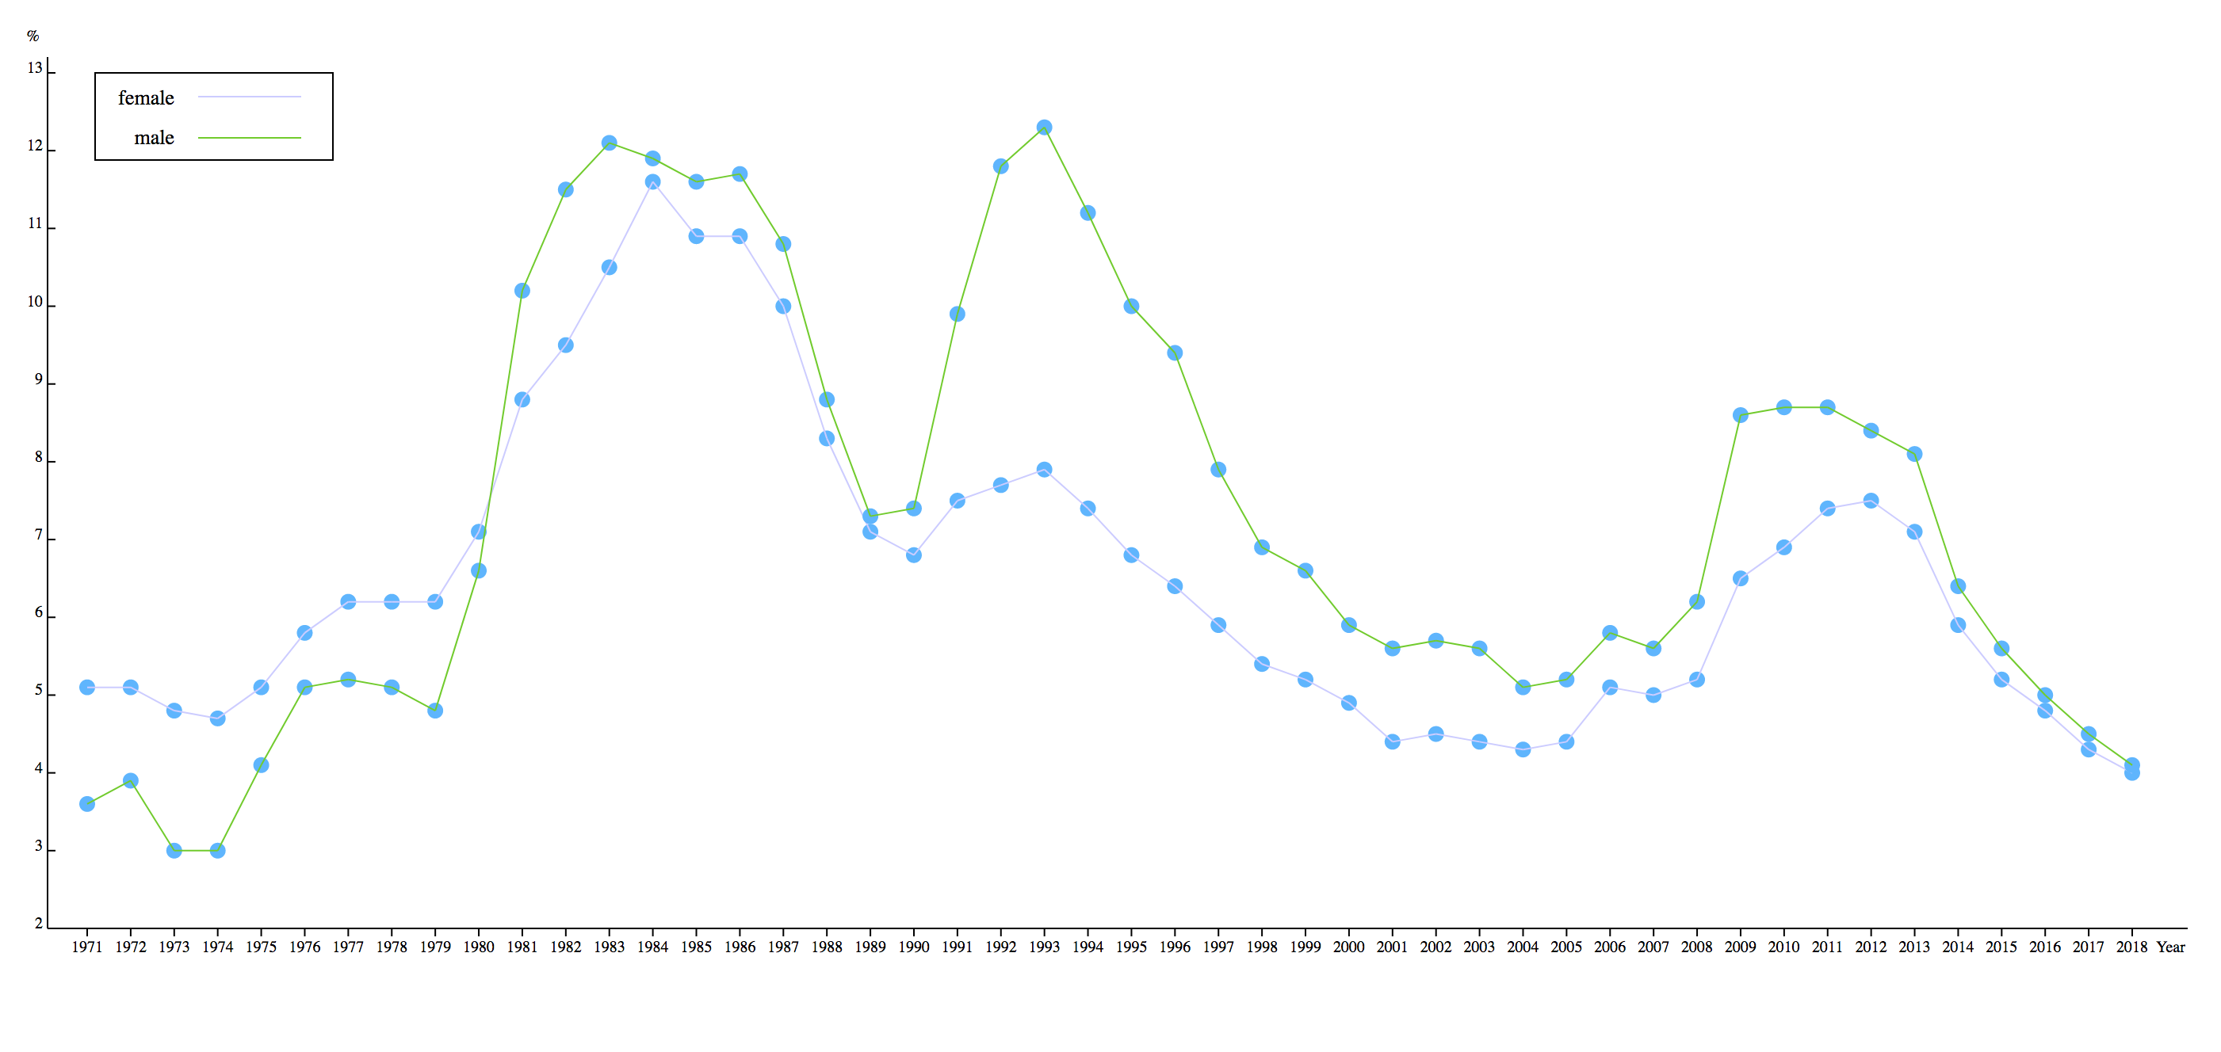

Draw this line chart with the following steps

First create the SVG container and design the width and height, then create and position the axes and set properties for them, via the drawAxis function.

With the axis, the body of the diagram can be added. First of all, I need to solve how to join the polyline. First, we need to generate a "line function" with line, and then pass the data to the function to generate the d we want. The d attribute of path is the most important, which determines the "path" of the polyline. This process is encapsulated in the drawLine function.

Then add points, because there is more than one circle, you need to use ‘selectAll’, and the circle does not exist yet. The role of selectAll('circle') can be understood as the position of a predetermined number of circles, and then the data is inserted into the ‘svg’ container.

Enter means that there is data, and each circle is placed in a separate g. There is no special purpose here, just like html is used to use div to load other elements.

Set some properties for the circle, cx, cy represents the x and y coordinates of the center of the circle. The function(d){} returns the x and y coordinates of the corresponding point on the polyline, so that the added circle is attached to the polyline. r represents the radius of the circle, and two mouse events are added to the circle, so that the animation of the circle data is added when the mouse moves and moves out of the circle.

Finally, add a rounded rectangle to the data of the point to display the data of the point.

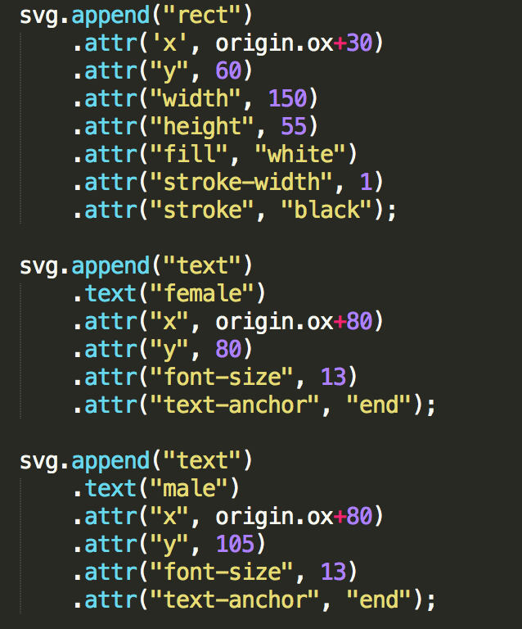

**Bar chart**

For the bar chart, I intercepted the 21st century data in order to compare the unemployment rate of male and female each year.

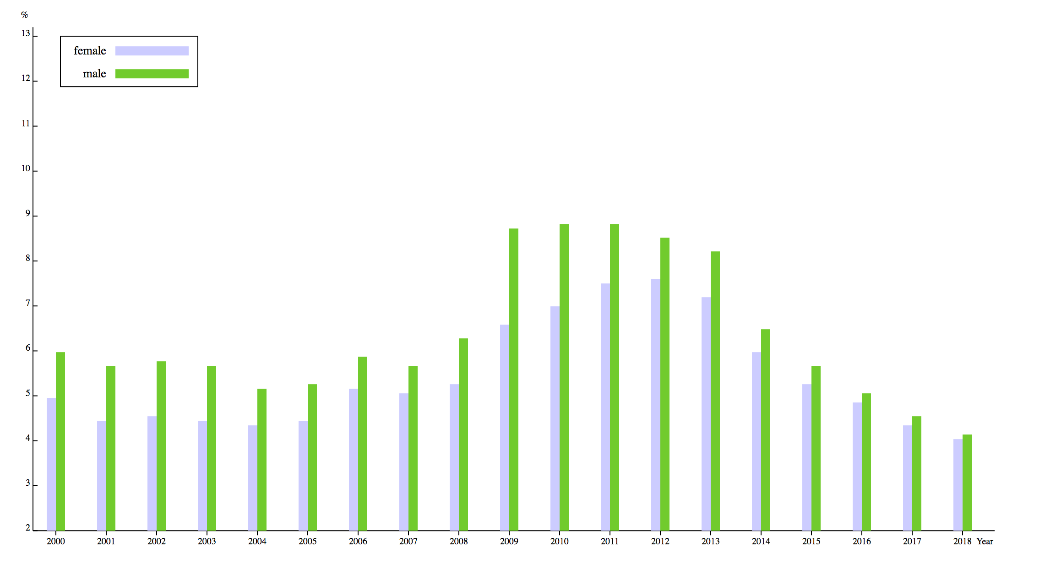

The production method is similar to the line drawing. I first sorted the year by the following code, and filtered and created the axis through the drawAxis function.

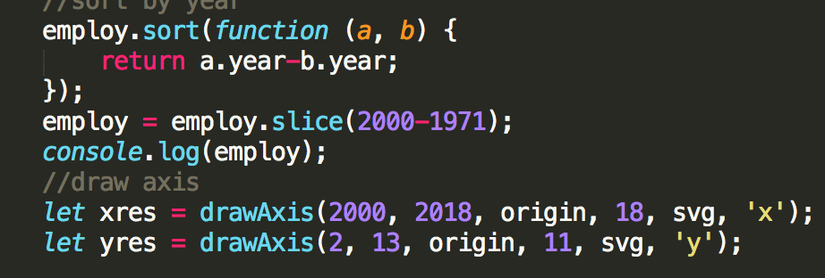

Then I added the rect element and assigns values, and adds properties to it.

I added an interactive effect to it in the same way, and the relevant value will appear when the user moves the mouse over it.

in conclusion

Through the two pictures, I found that from 1971 to 2018, the unemployment rate of men and women is constantly changing, but the trend of the two is the same. And between 1980 and 1981, men’s unemployment rate was greater than that of women, and it remained until 2018. However, through the histogram we find that the gap between the unemployment rate of men and women is constantly decreasing, and in the next five years, the unemployment rate of women may exceed that of men.

Finally, in this assignment, I encountered a problem that could not be solved. That is, Google Chrome cannot refer to local files, but can only use Firefox instead.